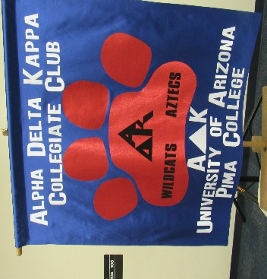
Collegiate Club Wish List
AZ A∆K is very pleased with the poise and spirit of our newly formed Arizona Collegiate Club with several members from Pima Community College who are transferring to complete their degree at the University of Arizona campus. The Club advisors, Maria Orozco and Donna Jurich, also became AZ Zeta members. Congratulations to all and a special thanks to Suzanne Maly and CeCe Hall for making this Collegiate Club possible!
If you choose to purchase any of the items listed below or would like to send a check to the A∆K Collegiate Club, you can send to:
Alpha Delta Kappa Collegiate Club
c/o Suzanne Maly
2918 E Sylvia St.
Tucson, AZ 85716

The Collegiate Club members were asked to create a WISH LIST that our Arizona chapters and/or members could help come to fruition. Let’s thank the following members for creating a list: Rosa Elena Calderon, Liliana Martinez, Kiara Imblum, Cynthia Dillman, Delanie Lynn Davis, and Julia Graziani.
WISH LIST ITEMS:
Gift cards to: Canes, Chipotle, Chick-Fil-A, Subway, Burger King, Starbucks
Store Gift Cards: Target, Walmart, Fry’s, Gas Stations, JanSport
Education Stores: Lakeshore, Scholastic
Printer, i-Pad, Wireless Printer
School supplies: Notebooks, Markers, Pens
Cricut Joy – a special paper cutter
Candles
Large hydro flask water bottle

